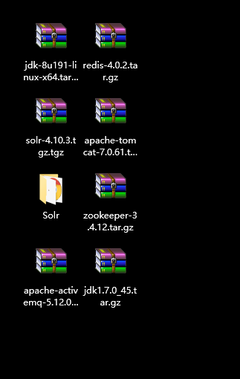

|  |
| --- |
| <!-- JMS服务厂商提供的ConnectionFactory -->  <bean id="targetConnectionFactory" class="org.apache.activemq.ActiveMQConnectionFactory">  <constructor-arg name="brokerURL" value="tcp://192.168.56.200:61616"/>  </bean>  <!-- spring对象ConnectionFactory的封装 -->  <bean id="connectionFactory" class="org.springframework.jms.connection.SingleConnectionFactory">  <property name="targetConnectionFactory" ref="targetConnectionFactory"></property>  </bean>  <!-- 配置消息的Destination对象 -->  <bean id="test-queue" class="org.apache.activemq.command.ActiveMQQueue">  <constructor-arg name="name" value="test-queue"></constructor-arg>  </bean>  <bean id="itemAddTopic" class="org.apache.activemq.command.ActiveMQTopic">  <constructor-arg name="name" value="item-add-topic"></constructor-arg>  </bean>  <!-- 配置消息的接收者 -->  <bean id="myMessageListener" class="com.dong.search.listener.MyMessageListener"/>  <bean class="org.springframework.jms.listener.DefaultMessageListenerContainer">  <property name="connectionFactory" ref="connectionFactory" />  <property name="destination" ref="test-queue" />  <property name="messageListener" ref="myMessageListener" />  </bean> |